

**ASSIGNMENT DOCUMENT**

**Project name**: Member management

**Dev**: Kieu Minh Duc

**Mentor**: Mr. Dung, Mr. Ha

# 1 Software Design

## Package diagram

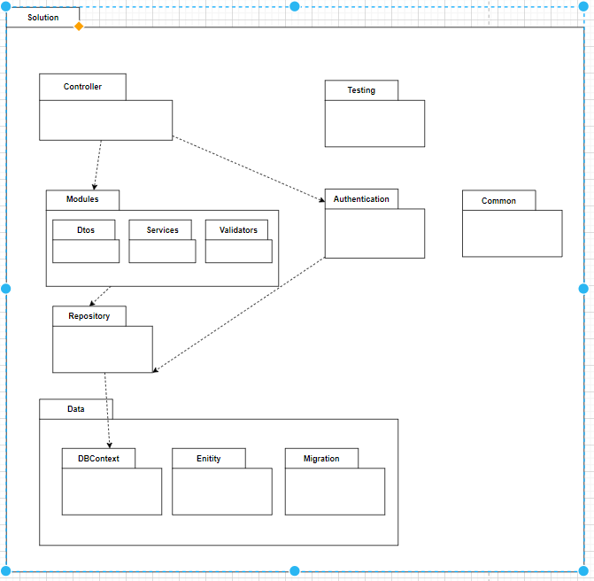

Package detail

|  |  |  |
| --- | --- | --- |
| No | Package | Description |
| 01 | Controller | The folder contains controllers |
| 02 | Testing | All test case for service define in this folder |
| 03 | Modules | The folder contains “Services” folders and “Validator” folders and “Dtos” folders |
| 04 | Services | All classes handling business rules |
| 05 | Dtos | Contain data transfer objects ,They as objects that used to encapsulate data, and send it from one subsystem of an application to another |
| 06 | Validators | The folder contains validation for data transfer object classes |
| 07 | Repository | The folder contains classes to get data from database |
| 08 | Common | The folder is global library for solutions. It contains global function, global class they reuse in other assemblies |
| 09 | DbContext | The folder contains classes to connect with database code first. It also define relationship of entities, constrains , and data type |
| 10 | Entity | Contains all entities |
| 11 | Migrations | Migrations are like version control for your database, allowing our team to modify and share the application's database schema. |

# 2 Guide

## **2.1 Step 1**

Change database connection for migration:

-Open DatacontextFactory.cs file and change connection configuration

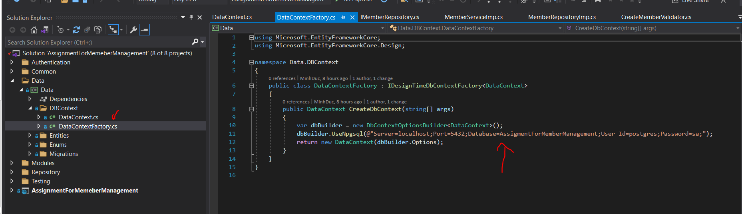

## **2.2 Step 2**

Set “Data/Data” as Startup project

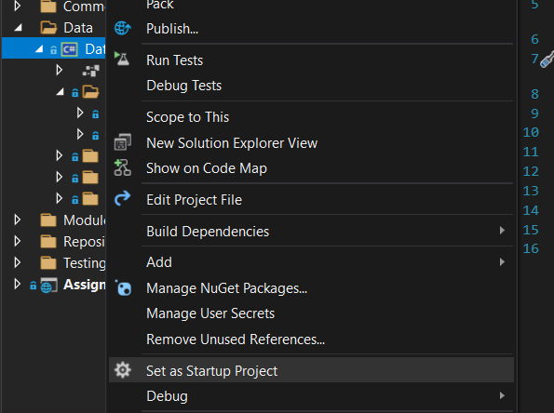

## **2.3 Step 3**

Migrate and update database

-Open “Package Manager Console” and Select “Datat\Data” as default project

-Write down “*add-migration _name_”*

ex: *”add-migration init”*

-Write down “update-database”

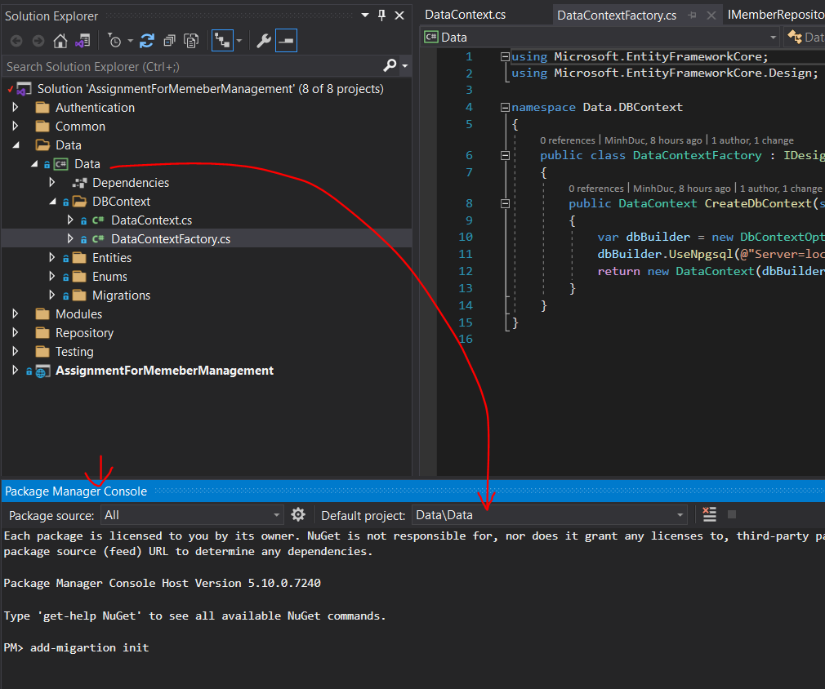

## **2.4 Step 4**

Change connection in “appsetting.json” file in “AssignmnetForMemberManagement” Project

